|  |  |  |
| --- | --- | --- |
| **Lyng Primary School P.E Knowledge Organiser** | | |
| **Topic: ACTIVITY GAMES/TARGET GAMES** | Year 2 | Autumn 1 |

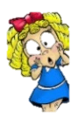



**Enquiry Questions**

* How do we able catch the ball whilst on the move?
* When do I know to use either an underarm or overarm technique to throw?
* How can we throw with accuracy?
* How to aim for a target that’s moving?
* How can I control the power I use to pass the ball?
* Can we bounce the ball multiple times without catching whilst on the move?

|  |  |
| --- | --- |
| **Key words** | |
| **Spelling** | **Definition** |
| Underarm | Throwing an object starting with your hands down moving in an upwards movement. |
| Dribble | When players dribble the ball in a game such as football or basketball, they keep kicking or tapping it quickly in order to keep it moving. |
| Score | In a sport or game, if a player scores a goal or a point, they gain a goal or point. |
| Accurate | To be accurate with a pass would be when aiming to give the ball to someone and its gets there, this is being accurate. |
| Passing | To transfer a ball to a team mate using our feet or hands depending on the sport. |
| Overarm | To Throw the ball or object with our hands above our head throwing in a direct motion to a target or person. |

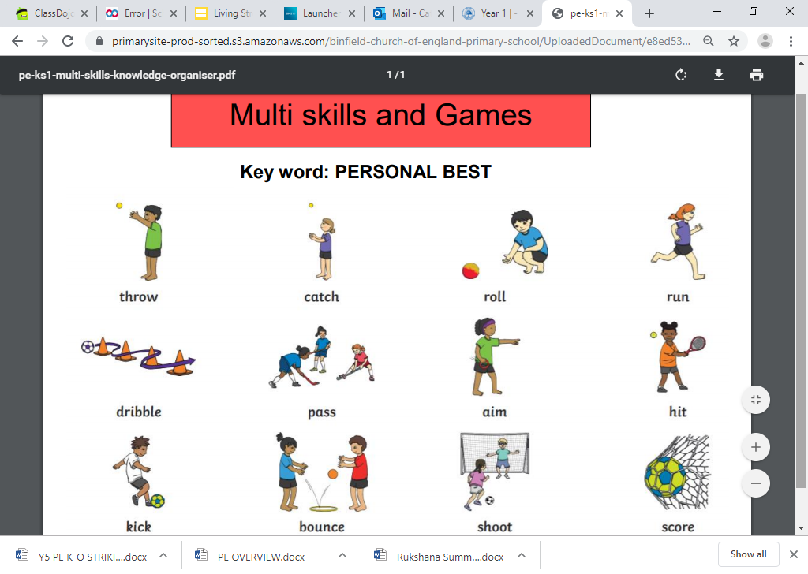

***“I failed over and over again that’s why I succeeded”***

**Michael Jordan**

**– Mav Levy**

|  |  |  |
| --- | --- | --- |
| **Lyng Primary School P.E Knowledge Organiser** | | |
| **Topic: ACTIVITY GAMES/TARGET GAMES** | Year 1 | Autumn 1 |

Learning Outcomes

* To practice throwing and catching from different distances
* To develop our underarm, overarm & bounce pass
* To throw objects into moving targets
* To identify which throw is needed to aim for a target
* To be able to control the ball when it is passed to us.
* To be able to bounce & move with a ball without catching it

